Episode 536: Vector bosons and Feynman diagrams

You need to check your own specification here for details of what students will need to do in examinations, and to look at past papers: although Feynman diagrams give clarity to particle interactions, they are not required by all specifications.
virtual photon
e⁻
e⁻
e⁻
e⁻
Summary
Demonstration: Exchange particles.
(5 minutes)
Discussion: Interactions of different types.
(15 minutes)
Demonstration: Model Feynman diagrams.
(15 minutes)
Discussion: Rules for Feynman diagrams. (10 minutes)
Student activity: Constructing Feynman diagrams. (20 minutes)

Demonstration:
Exchange particles
Yukawa’s theory of an exchange particle to explain repulsive and attractive forces in nuclei is worth demonstrating with two students and a football or other large object.
If two students throw (gently) a heavy object such as a schoolbag or football to each other, each will report feeling an outwards force both on throwing and on catching (Why? Conservation of momentum). If the rules are changed so that, instead of throwing, each student pulls the object from the other’s hands in turn, then each will report feeling an inwards force both on gaining and on losing the particle.

Discussion:
Interactions of different types
This crude model in the demonstration above will illustrate the idea of an exchange particle originated by Yukawa, who suggested that a nuclear exchange particle (it turned out to be the pion) could explain the strong interaction between protons and neutrons. In the last episode, it will be clear that a similar fundamental exchange works at a level that is more fundamental than mesons and baryons.
The electromagnetic interaction, which consists of just the well-known attractions and repulsions of static electricity (pre-16 level), is a different interaction, much weaker than the strong interaction. Here the exchange particle is the photon.
The weak interactions, which are harder to classify, and are similar in strength to the electromagnetic interactions, are associated with changes in the nature of particles.

Demonstration:
Model Feynman diagrams
Feynman diagrams can be introduced via a physical model that can be twisted to show different interactions. The key aspects – direction of time, transfer of the force-carrying boson, difference between particles and anti-particles – can be quickly illustrated for an electromagnetic interaction.
As an example of these points (including the last), you may wish to use a simple physical model. It is quick and easy to use cheap coat hangers linked by their hooks, with triangles of card attached midway across the ‘shoulder’ of each. The supporting ‘shoulders’ of the coat hangers are the interacting particles, while the interlocked hooks constitute the vector boson. With one twist each time, it is possible to go from electron-electron interaction to electron positron interaction to positron-positron interaction to electron-positron annihilation.
For these electromagnetic interactions, the particle exchanged is a photon. For the weak interaction, there are three particles, depending on the changes in charge taking place. If you deal with quark interactions later, the exchange particle is the gluon.

Some teacher notes:

TAP 536-1: Feynman diagrams

TAP 536-2: Coat-hanger Feynman diagrams

Discussion:
Rules for Feynman diagrams
If your specification requires Feynman diagrams, you will need to emphasise the rules for drawing them. These are not consistent from source to source! In this episode, the following conventions are followed.
Time goes vertically up the diagram (many sources have time horizontal).
Side-to-side displacement in the diagrams has no meaning other than to show separate particles. If two paths are heading outwards, it does not imply that particles are repelling each other.
Particles are shown by ‘normal’ arrow-heads, while anti-particles are shown by reversed arrow-heads (remember that the direction of time is upwards), so a collision between a proton and an anti-proton can be represented as:
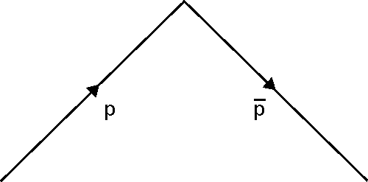

From any vertex, such as the collision point of the proton and anti-proton, a boson can be drawn. This can be a photon (wavy line), a weak interaction boson (a dotted line)
A Feynman diagram – certainly the simple ones in this episode – can be pivoted about any of the vertices to produce another valid diagram.

Student activity:
Constructing Feynman diagrams
Students are supplied with cards from which they can construct Feynman diagrams. They use the different ‘left-hand sides’ of the diagrams with the single vector boson and the appropriate ‘right-hand side’ to produce the different possible weak interactions, and then to label the boson with W⁺, W⁻ or Z⁰ as appropriate.

TAP 536-3: Feynman diagram student activities

TAP 536-4: Feynman weak interaction cards

TAP 536- 1: Feynman diagrams

Teacher notes
A Feynman diagram is not a picture in space of the paths of actual particles. It is a picture of the structure of one of the terms that contributes to the total “quantum amplitude” for a process. A ‘process’ here is an event in which definite particles enter and definite particles leave. A ‘quantum amplitude’ is a measure of the likelihood of the process happening. For example, scattering of a pair of electrons has two electrons enter and two leave. Here are some of the terms that Feynman diagrams keep track of and all of which have to be taken into account to obtain the final amplitude:

No photon exchanged. The amplitude for these terms just contains an expression for an electron propagating from one place to another. Here we have included terms obtained by interchanging the indistinguishable electrons. Both have to be counted in.

One photon exchanged. The expression for the amplitude is now a product of four expressions for electrons going from place to place, one expression for a virtual photon going from place to place, and two couplings of electron to photon.

A further term (omitting ones which involve interchanging electrons). Here an electron emits a virtual photon and absorbs it again.
Photon emits an electron-positron pair, which then recombines. This term has four couplings of electron (or positron) with a photon. Each introduces a factor of the electronic charge into the product giving the amplitude.

Doing the adding up
The expression for each diagram has to be integrated over all space-time positions for the particles and where they interact. They are also integrated over all possible energies and momenta. This gives a total quantum amplitude (‘arrow’) for each diagram.
Finally, the arrows for all computed diagrams are added to give a final arrow.

Practical advice
We strongly recommend that you read Feynman’s ‘QED: The Strange Theory of Light and Matter’, particularly chapters 3 and 4. It gives a very clear picture of the nature of Feynman diagrams, and the calculations made using them, without technical detail. A careful reading will amplify several of the teaching notes above

External reference
This activity is taken from Advancing Physics chapter 17, further teaching notes
TAP536- 2: Coat-hanger Feynman diagrams

One way of showing Feynman diagrams is by using coat-hangers and cardboard triangles.

Electron-electron interaction

Electron-positron interaction

Positron-positron interaction

Electron-positron annihilation

TAP 536 - 3: Feynman diagram student activities

This is the Feynman diagram for an electron interacting with another electron by the electromagnetic interaction.

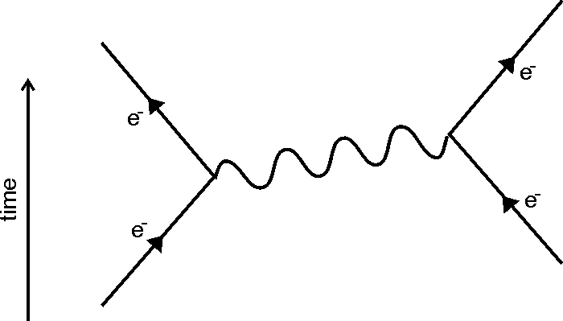

In a Feynman diagram, the electromagnetic interaction is shown by the exchange of a photon. The ‘left hand’ electron emits a photon, and changes direction. The ‘right hand’ electron absorbs the photon, and also changes direction.
In a Feynman diagram,
- Time goes upwards. (This is not consistent. Some particle physicists prefer to have time going sideways.)
- Particles are shown by arrows going upwards
Antiparticles are shown by arrows going downwards, so the electromagnetic interaction between two positrons (the anti-particles of electrons) is
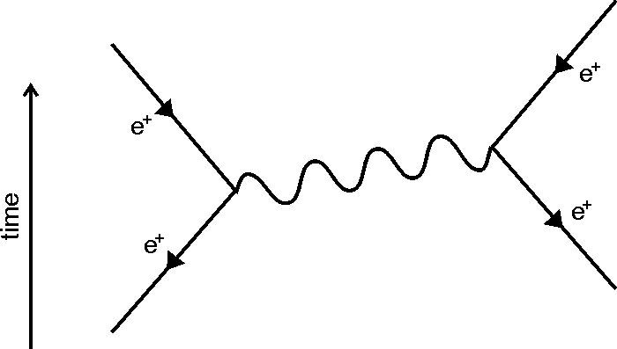
The outwards movement after emitting or absorbing a photon just shows a change in direction. It does not mean that they particles are repelling each other. As an example, the attraction between an electron and a positron is
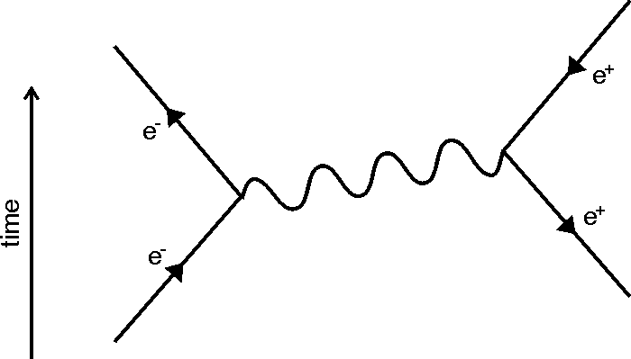

The photon (wavy line) in the electromagnetic interaction is called a vector boson.
- Vector – carries the interaction
- Bosons – the type of particles that carry interactions.
In the weak interaction, there are three vector bosons: the W⁺, W⁻ and Z⁰ bosons. On Feynman diagrams, these are shown by dotted lines.
The first two weak interaction bosons are charged, and are emitted when the ‘left hand’ particle changes its charge. If a proton turns into a neutron, for example, it emits a W⁺.

You have the following cards
Four ‘left hand’ cards, similar to the electron in the third example above
One ‘middle’ card to serve as the vector boson (dotted)
Four ‘right hand’ cards, similar to the positron in the third example above. Three vector boson labels: W⁺, W⁻ and Z⁰ to put on top of the ‘middle’ card.
1. Use these cards to construct four possible weak interactions. Make sure that your reaction conserves charge as well as baryon number and lepton number.

2. Label each diagram with one of these titles:
- Beta-minus decay
- Beta-plus decay
- Electron capture
- Neutrino-neutron collision

3. For each one, write the equation.
Answers and worked solutions
2. Beta-minus decay
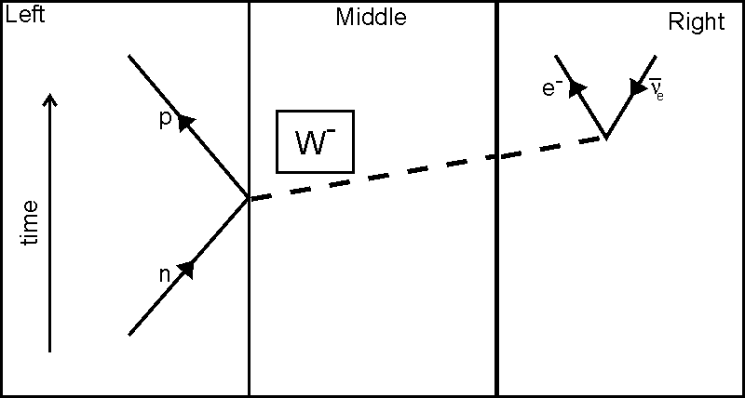
Beta-plus decay
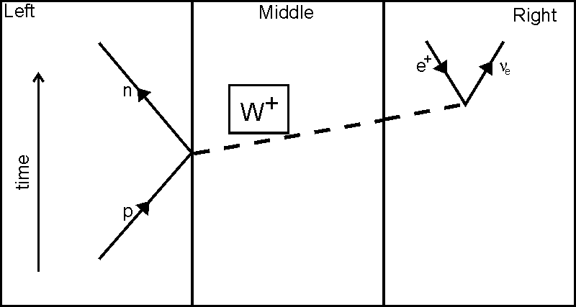
Electron capture
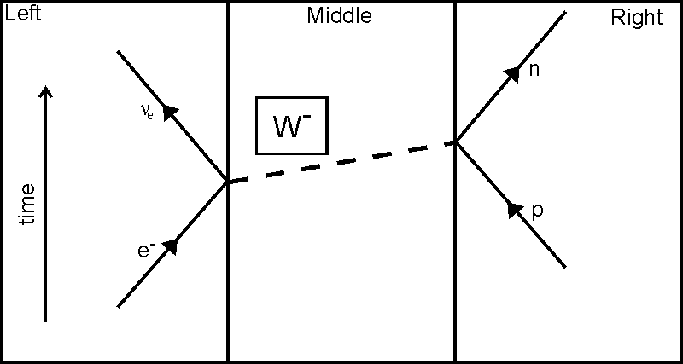
Neutrino-neutron collision
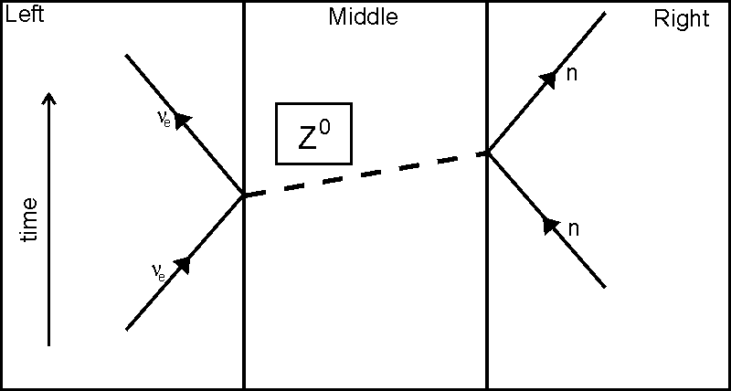

It is worth emphasising how the diagrams show conservation of baryon number (upward arrow head before and after the vertex on the baryon path), conservation of lepton number (upward arrow head before and after the vertex for the electron capture and the neutrino-neutron collision, or no lepton becoming and upward and a downward arrow after for the two beta decays) and conservation of charge, including the vector boson, reading from left to right.
3. n → p + e⁻ + ν_{e}bar
p → n + e⁺+ ν_{e}
p + e⁻ → n + ν_{e}
ν_{e} + n → n + ν_{e}

TAP 536 - 4: Feynman weak interaction cards

